BASIC TAGS :
Ex no : 0
Date : 28/01/2026
Name : Naresh S
Reg no : 240391771051

SOURCE CODE (index.html):
<!DOCTYPE html>
<html>
<head>
<title>HTML Basic Commands</title>
<link rel="stylesheet" href="style.css">
</head>

<body id="page">

<h1 id="main-heading">HTML - HYPERTEXT MARKUP LANGUAGE</h1>

<hr id="top-line">

<p id="description">
HTML, or <b>HyperText Markup Language</b>, is the standard, foundational language used to create and structure web pages.
It acts as the skeleton for all websites, using a system of tags and elements to define content, such as headings,
paragraphs, images, and links for web browsers. It is not a programming language, but a markup language that determines
how content is organized on a page.
</p>

<hr id="bottom-line">

<img
src="https://encrypted-tbn0.gstatic.com/images?q=tbn:ANd9GcQPim9fWU4lLLwwIBaB7VsQQ_Fk3Ka7uxWHmA&s"
alt="HTML Image"
id="html-image"
>

<table id="table" border="1" cellpadding="10" cellspacing="0">
<tr>
<td><b>TAGS</b></td>
<td><b>DESCRIPTION</b></td>
</tr>
<tr>
<td>&lt;head&gt;</td>
<td>Contains meta information about the document like title, styles, and scripts.</td>
</tr>

<tr>
<td>&lt;title&gt;</td>
<td>Defines the title of the web page shown on the browser tab.</td>
</tr>

<tr>
<td>&lt;body&gt;</td>
<td>Contains all the visible content of the web page.</td>
</tr>

<tr>
<td>&lt;p&gt;</td>
<td>Defines a paragraph of text.</td>
</tr>

<tr>
<td>&lt;br&gt;</td>
<td>Inserts a single line break.</td>
</tr>

<tr>
<td>&lt;hr&gt;</td>
<td>Creates a horizontal line to separate content.</td>
</tr>

<tr>
<td>&lt;img&gt;</td>
<td>Embeds an image in the web page.</td>
</tr>

<tr>
<td>&lt;a&gt;</td>
<td>Creates a hyperlink to another page or resource.</td>
</tr>

<tr>
<td>&lt;ul&gt;</td>
<td>Defines an unordered (bulleted) list.</td>
</tr>

<tr>
<td>&lt;ol&gt;</td>
<td>Defines an ordered (numbered) list.</td>
</tr>

<tr>
<td>&lt;li&gt;</td>
<td>Defines a list item inside ul or ol.</td>
</tr>

<tr>
<td>&lt;table&gt;</td>
<td>Creates a table to organize data.</td>
</tr>

<tr>
<td>&lt;tr&gt;</td>
<td>Defines a row in a table.</td>
</tr>

<tr>
<td>&lt;td&gt;</td>
<td>Defines a data cell in a table.</td>
</tr>

<tr>
<td>&lt;th&gt;</td>
<td>Defines a header cell in a table.</td>
</tr>

</table>

<br>
<hr>
<h2>HTML FORM TAGS</h2>
<h3>List of form tags</h3>
<ul type = "circle">
<li>&lt;form&gt; - Defines an HTML form for user input</li>
<li>&lt;input&gt; - Defines an input control</li>
<li>&lt;textarea&gt; - Defines a multiline input control (text area)</li>
<li>&lt;button&gt; - Defines a clickable button</li>
<li>&lt;select&gt; - Defines a drop-down list</li>
<li>&lt;option&gt; - Defines an option in a drop-down list</li>
</ul>
<form id="reg-form">
<fieldset>
<legend>REGISTRATION FORM</legend>

<table id="form-table">
<tr>
<td><label for="name">Full Name</label></td>
<td><input type="text" id="name" name="name" placeholder="Enter your name" required></td>
</tr>

<tr>
<td><label for="email">Email</label></td>
<td><input type="email" id="email" name="email" placeholder="Enter your email" required></td>
</tr>

<tr>
<td><label for="password">Password</label></td>
<td><input type="password" id="password" name="password" required></td>
</tr>

<tr>
<td>Gender</td>
<td>
<input type="radio" name="gender" value="male"> Male
<input type="radio" name="gender" value="female"> Female
</td>
</tr>

<tr>
<td>Skills</td>
<td>
<input type="checkbox" name="skill" value="html"> HTML
<input type="checkbox" name="skill" value="css"> CSS
<input type="checkbox" name="skill" value="js"> JavaScript
</td>
</tr>

<tr>
<td><label for="country">Country</label></td>
<td>
<select id="country" name="country">
<option value="">--Select--</option>
<option value="india">India</option>
<option value="usa">USA</option>
<option value="uk">UK</option>
</select>
</td>
</tr>

<tr>
<td><label for="dob">Date of Birth</label></td>
<td><input type="date" id="dob" name="dob"></td>
</tr>

<tr>
<td><label for="message">Address</label></td>
<td>
<textarea id="message" name="message" rows="4" cols="30"></textarea>
</td>
</tr>

<tr>
<td></td>
<td>
<button type="submit">Register</button>
<button type="reset">Clear</button>
</td>
</tr>
</table>
</fieldset>
</form>

<h3>HTML - TUTORIAL VIDEO</h3>
<video width="600" controls id="vid">
<source src="https://www.w3schools.com/html/mov_bbb.mp4" type="video/mp4">
Your browser does not support the video tag.
</body>
</html>

STYLE.CSS:

#page {
background-color: #f4f6f8;
font-family: Arial, Helvetica, sans-serif;
margin: 0;
padding: 20px;
}

#main-heading {
text-align: center;
color: #2c3e50;
font-family:'Times New Roman', Times, serif;
letter-spacing: 1px;
}

#top-line,
#bottom-line {
width: 80%;
margin: 20px auto;
border: 1px solid #ccc;
}

#description {
width: 80%;
margin: auto;
font-size: 18px;
line-height: 1.6;
color: #333;
text-align: justify;
background-color: #ffffff;
padding: 20px;
border-radius: 8px;
}

#html-image {
display: block;
margin: 30px auto;
width: 300px;
height: 220px;
border-radius: 10px;
box-shadow: 0px 4px 20px rgb(0, 0, 0);
}

#html-image:hover {

box-shadow: 0px 8px 20px rgb(0, 0, 0);

}
table,th,td
{
border : 3px solid black;
border-collapse : collapse;
padding : 2px;
margin-left:80px;
}

#reg-form {
width: 80%;
margin: 30px auto;
background-color: #ffffff;
padding: 15px;
border-radius: 10px;
}

fieldset {
border: 2px solid #2c3e50;
padding: 10px;
}

legend {
font-size: 20px;
font-weight: bold;
color: #2c3e50;
}

#form-table {
width: 100%;
border: none;
}

#form-table td {
padding: 6px;
border: none;
}

input, select, textarea {
width: 50%;
padding: 3px;
border-radius: 5px;
border: 1px solid #aaa;
}

button {
padding: 4px 8px;
background-color: #2c3e50;
color: white;
border: none;
border-radius: 5px;
cursor: pointer;
}

button:hover {
background-color: #1a252f;
}

#vid
{
display: block;
margin: 20px auto;
border-radius: 10px;
box-shadow: 0px 4px 20px rgb(0, 0, 0);
}

OUTPUT:
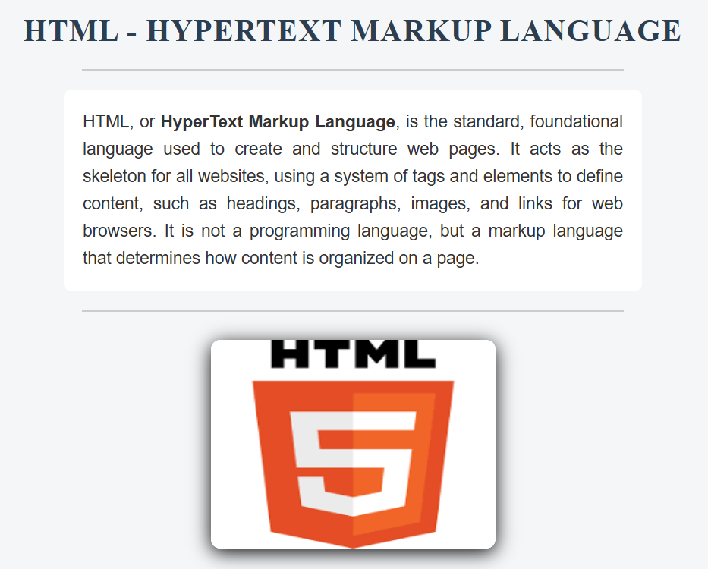

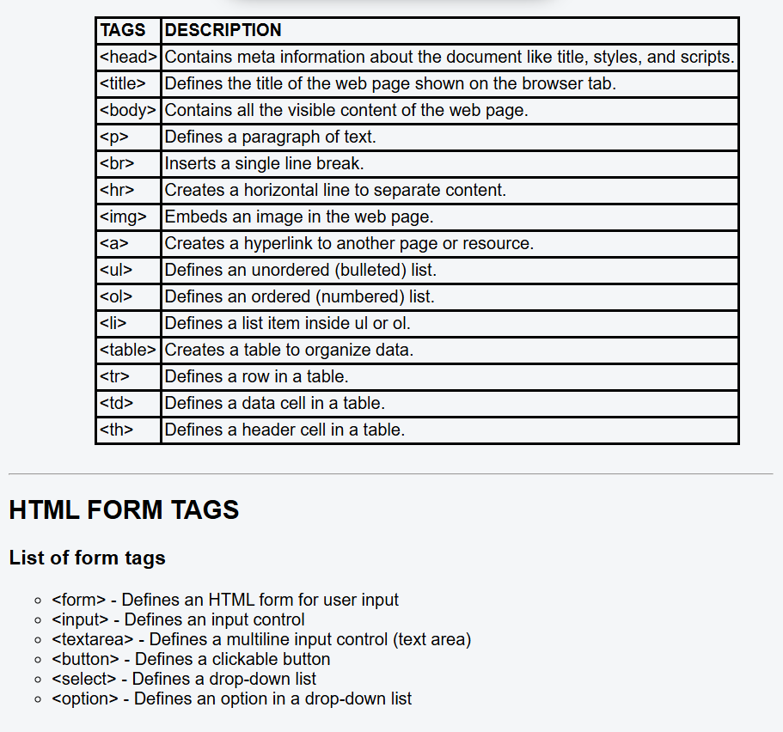

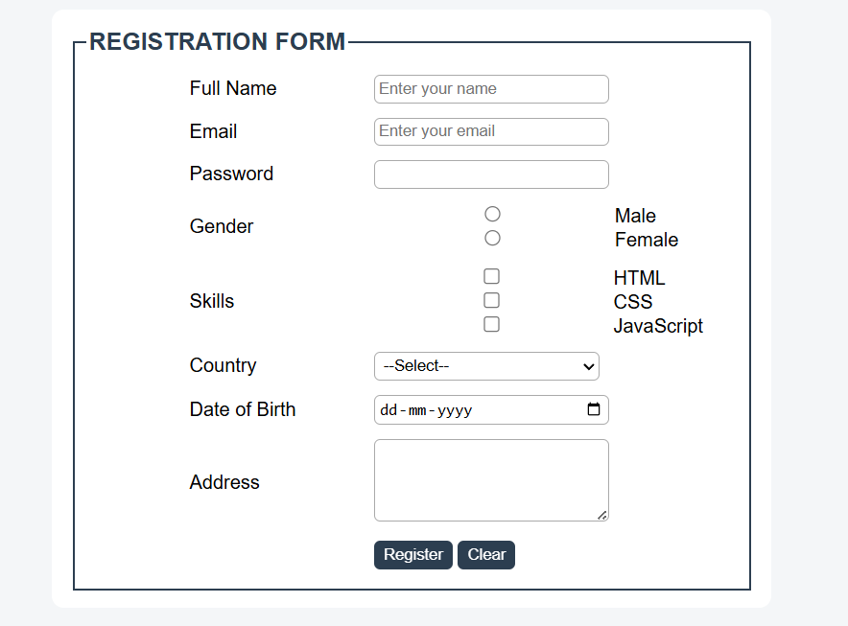
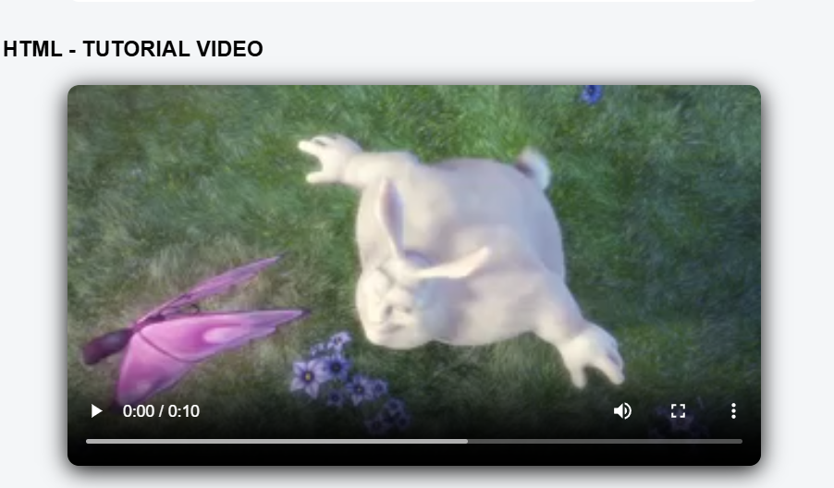

TAGS USED:

Document Structure Tags
- <!DOCTYPE html>: Declares that the document follows HTML5 standards.
- <html>: Acts as the root element that contains the entire HTML document.
- <head>: Contains meta information such as title and linked CSS files.
- <title>: Specifies the title displayed on the browser tab.
- <body>: Holds all the visible content of the web page.

Text & Content Formatting Tags
- <h1>: Defines the main heading of the web page.
- <h2>: Defines a second-level heading.
- <h3>: Defines a third-level heading.
- <p>: Used to display a paragraph of text.
- <b>: Makes the enclosed text bold.
- <hr>: Creates a horizontal line to separate sections.
- <br>: Inserts a single line break.

Media Tags
- <img>: Used to embed an image in the web page.
- <video>: Used to embed a video in the web page.
- <source>: Specifies the media source for video or audio elements.

Table Tags
- <table>: Used to create a table for displaying data.
- <tr>: Defines a row inside a table.
- <td>: Defines a data cell inside a table.
- <th>: Defines a header cell inside a table.

List Tags
- <ul>: Creates an unordered list.
- <li>: Defines a list item inside a list.

Form Tags
- <form>: Defines an HTML form to collect user input.
- <fieldset>: Groups related form elements together.
- <legend>: Provides a caption for the fieldset.
- <label>: Defines a label for an input element.
- <input>: Used to accept user input in different forms.
- <textarea>: Allows multi-line text input.
- <select>: Creates a drop-down list.
- <option>: Defines options inside a drop-down list.
- <button>: Creates a clickable button.

